Kappaphycus alvarezii (syn. K. cottonii) is a species of red alga. It is one of the most important commercial sources of carrageenans, a family of gel-forming, viscosifying polysaccharides. Farming methods affect the character of the carrageenan that can be extracted from the seaweed.^{[1]}
Refer kappaphycus pdf for general info.
Kingdom: | Archaeplastida
Phylum: | Rhodophyta
Class: | Rhodophyceae
Order: | Gigartinales
Family: | Solieriaceae
Genus: | Kappaphycus
Species: | K. alvarezii

This alga grows to two meters long and is green or yellow in color.^{[2]} It is very fast-growing, known to double its biomass in 15 days.^{[2]}
Different carrageenan types differ in composition and conformation, resulting in a wide range of rheological and functional properties. Carrageenans are used in a variety of commercial applications as gelling, thickening, and stabilizing agents, especially in food products such as frozen desserts, chocolate milk, cottage cheese, whipped cream, instant products, yogurt, jellies, pet foods, and sauces. Aside from these functions, carrageenans are used in pharmaceutical formulations, cosmetics, and industrial applications such as mining.^{[3]} Carrageenan is extracted from this seaweed in two ways. In native extraction, the seaweed is made into an aqueous solution, and the residue is filtered, leaving nearly pure carrageenan. The alkaline-modified method is less expensive and easier. The seaweed is mixed in an alkali solution, leaving a mixture of carrageenan and cellulose that can be sold as semirefined carrageenan.
K. alvarezii is affected by ice-ice, a disease that severely reduces its yield.
This alga is an introduced species and a noxious aquatic weed in Hawaii.^{[2]}
However, recent molecular studies have revealed the most abundant species in Hawaii reported to caused an invasion on the coral reefs is actually Euchema denticulatum and not K. alvarezii.^{[4]} K. alvarezii has been and will be introduced into many different tropical places, since it is the main source of carrageenan in the world. Several thousands coastal people can be benefit from its cultivation. Most notably, it is increasingly being cultivated on the coasts of Rameshwaram, India. The local people call it, Pepsi Paasi since it was the PepsiCo which started the cultivation of this alga here.

Eucheumoid algae
By Dr Leila Hayashi (Universidade Federal de Santa Catarina, Florianópolis, Brasil)
Kappaphycus alvarezii (Fig. 1, below), Kappaphycus striatum and Eucheuma denticulatum belong to a group of commercially important species known as the “Eucheumoid algae” and are known in the trade as “cottonii” and “spinosum”. These three species are the main source of kappa and iota carrageenan, being responsible for about 88% of worldwide raw material.
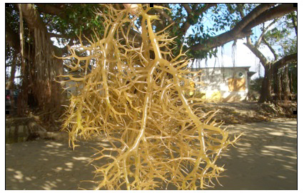
Figure 1: Brown strain of Kappaphycus alvarezii cultivated in Florianópolis, Santa Catarina, Brazil. Picture © Leila Hayashi taken on24/04/2009.
Statistical data from the FAO's (Food and Aquaculture Organization of United Nations) Fisheries and Aquaculture Departments show that the production in 2007 of these three species was about 1.6 million wet tons, with a landed value of some US$175 million.
Commercial farms are located mainly in the Philippines, Indonesia, Tanzania, Mozambique, Zanzibar, and a few Pacific Islands. The success of these farms resulted in the introduction of Kappaphycus and Eucheuma to more than 25 countries, but many of them ceased farming at an experimental stage.

Cultivation methods
Cultivation of eucheumoid algae is really simple under the right conditions. It is based on vegetative propagation. These species can grow easily when attached on ropes, reaching growth rates between 3-8% per day. There are several cultivation methods: off-bottom, rafts, and long-lines.
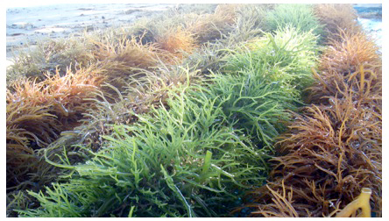
Figure 2: Brown, green and red strains of Kappaphycus alvarezii planted in tubular nets (see text), cultivated in Florianópolis, Santa Catarina, Brazil. Picture © Leila Hayashi, taken on 21/05/2009.
The off-bottom method uses stake, which hold the ropes with the propagules attached, and must be done in shallow and clean water. Rafts are frequently used in deeper waters but require boats to go to the farms. The structure to keep the ropes inside the water is provided by rafts, made from bamboo, wood or PVC pipe, instead of stakes. Long-lines can be used as in off-bottom, as in the raft methods, and is a more intensive cultivation process. It is recommended when large areas are being used.
Raft culture. Wooden poles are laid parallel to each other about 0.5 m. apart and fastened by wire lashing to lateral beams. Each beam is used to suspend the seed oysters from the raft. The floats for the raft are usually made from styrofoam. A raft is normally 18 m long and 9 m wide and the float materials range from 30 to 40 pieces. About 400 to 500 strings of oysters can be suspended from the raft. One string is 9 m long (Figure 5-5).
Long-line culture. The long-line culture is a modification of raft culture. This method is used for offshore culture. The basic feature of a long-line unit is a series of styrofoam floats arranged in a row. The long-line is secured at each end with two anchors. One long-line is 100 m long and consists of about 51 floats connected by a polyurethane rope 15 mm in diameter. A series of strings of oysters called “rens”, each about 5m long (the exact length varies with the depth of water) is suspended to each rope (Figure 5-6).
Traditionally, propagules are attached to the ropes in a system known as “tie-tie”, in which each plant is tied with plastic strings or ties. Nowadays, variations of this method are used, such as the “made-loop”, in which a plastic string is tied into a loop tied on the rope, and the tubular nets commonly utilized in mussel cultivation (Fig. 2, above). This last methodology has been very effective in Brazilian cultivation.

Harvesting and processing
Production cycles vary from 30 to 60 days, depending on the farming region and method. If the propagules are attached in the ropes with the “tie-tie” method, then the harvesting consists only in untying or cutting the plastic strings or ties. If the propagules are attached using the “made-loops” or tubular nets, the harvesting is done with the help of a “line stripper”: a wooded piece with holes of different sizes, which the cultivation rope is fed through, stripping the seaweeds.
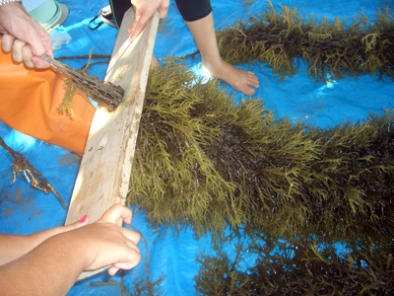
Figure 3: "Line stripper" used for Kappaphycus alvarezii harvesting. Picture © Leila Hayashi, taken on 04/02/2010.
After harvesting, the seaweeds are washed several times with seawater to remove sediments, and sun-dried (Fig. 4, below) until they reach the commercial moisture content (30-40%). Dried seaweed is normally bailed to facilitate the transportation, and even the exportation. Seaweed farmers can sell the collected biomass to stackers, or the bales directly to traders who will forward the production to exporters and international processors. Farmers can be organized in cooperatives, and these can facilitate the relationship between them and the traders.
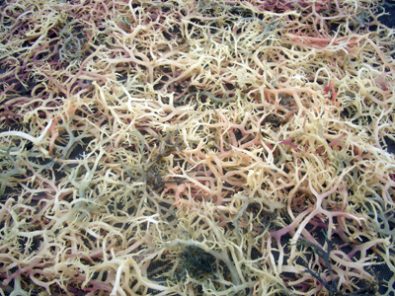
Figure 4: Sun-dried Kappaphycus alvarezii samples from experimental farming of Florianópolis, Santa Catarina, Brazil. Picture taken 08/02/2010 by Leila Hayashi.

Carrageenan extraction procedures
There are two main kinds of carrageenan extracts, different according to the extraction methodology employed: semi-refined and refined carrageenan.
In semi-refined carrageenan extraction, clean seaweed is cooked in an alkali solution to improve the gel strength, and then washed several times and laid out to dry in the sun. Later, the alkali-treated material is ground and sold as seaweed flour. This process is much shorter and cheaper than refined carrageenan process. However, semi-refined carrageenan has different applications than the refined carrageenan: it is usually used for canning meat and for pet food, and products in which the presence of coloring does not matter.
Refined carrageenan is obtained after a pre-treatment with alkali solution, followed by cooking in water. The seaweed residue is removed by filtration and the carrageenan is recovered from the solution by precipitation with isopropyl alcohol, or by repeatedly freezing and thawing the gel until water is totally eliminated from the carrageenan fibers. The fibers are then dried and ground in the same way of semi-refined carrageenan. The result product is practically “pure” carrageenan, without any residue of seaweed, and can be used in food industry for refined products like desserts, puddings, amongst many other things, because it is colorless.

Introduction of exotic species
Eucheumoid seaweeds are commercially important, and their success stimulated the introduction to many countries. However, in some places, introduced species became a problem, such as in India and Hawaii, where the species began to overgrow coral reefs, and in the Phillipines, Malaysia and India, where epiphyte outbreaks induced loss of entire crops (see Ask et al. 2003).
Normally, compared to other aquaculture activities, seaweed farming is one of the lest environmentally-impactating activities, but care must be taken to avoid future difficulties, particularly when dealing with introduced species. Selection of adequate sites, environmental monitoring (mainly related with the bio-dispersion), and quarantine protocols must be made to guarantee the success of the activity.
Amino acid, fatty acid and minerals of Kappaphycus sp. were determined. Amino acids were estimated by HPLC method where as fatty acids by gas chromatography. Total 18 amino acids were found in the dried species, lysine is the major constituent and followed by asparagines, histidine, isoleucine, phenylalamine, tryptophan. In the case of fatty acids, eight components were identified including two components, namely, palmitic and cervonic acids are in traces. Alpha linolenic (n-3) and linoleic acids are found to be the major components. Macrominerals were identified by using flame atomic absorption spectrophotometry and found that red algae contained various macrominerals, namely, Sodium (23.4 mg), Potasium (12.44 mg), Magnesium (23.56 mg), Phosphorous (19.5 mg) per 1000mg and rich in Calcium (3.565 gm/100 gm). It was observed that Na/K ratio is below 2.0 which is interesting to note that Kappaphycus sp. could be used as a food supplement.

